TAG MANAGEMENT

Tag management solutions available:

1. Launch by adobe
2. Tealium
3. Google tag manager
4. Signal
5. Qubit
6. Ensighten
7. Tag commander
8. Piwik PRO
9. IBM DDX
10. YOTTA

A tag is a short snippet of code, usually from a third-party vendor, that companies implement on their site to collect data for analytics and digital marketing tools.

Traditionally, marketers and analysts had to submit a ticket to IT every time they wanted to deploy or update a tag, making it harder for data-driven professionals to be agile and measure quickly. Tag management systems (TMSs) make it possible for marketers and analysts to deploy and manage the tags on their site without relying wholly on IT.

Instead of deploying each tag individually, companies can instead deploy a TMS container code and, within a TMS interface, set rules for when any other tags should fire.

Each tag management system has its strengths.

Tag management is not the most exciting name for a crucial technology, often being confused with blog tags, tag clouds or search engine meta tags. Tag management is not related to any of those. Tags are a means to collect and move data between a website or mobile app session, and the technology vendor. Nevertheless, that is how the industry evolved, and the name stuck, although it is quickly becoming part of a larger data conversation.

A tag management system is a SaaS solution that simplifies how all of your web-based technologies are installed, managed, and used. Tag management systems democratize tagging by providing easier and more efficient ways for less technical contributors, such as marketers and content managers, to deploy solutions across the site. So instead of asking IT to manually place every tag on every web page by hand, marketers can deliver compelling experiences faster by deploying IT-approved tags on their own.

/ss & b/ss – Adobe analytics

/collect – Google analytics

WEB ANALYTICS TOOLS

**Web analytics** is the measurement, collection, analysis and reporting of web data for purposes of understanding and optimizing web usage.However, Web analytics is not just a process for measuring web traffic but can be used as a tool for business and market research, and to assess and improve the effectiveness of a website. Web analytics applications can also help companies measure the results of traditional print or broadcast advertising campaigns. It helps one to estimate how traffic to a website changes after the launch of a new advertising campaign. Web analytics provides information about the number of visitors to a website and the number of page views. It helps gauge traffic and popularity trends which is useful for market research.

Two main web analytics

1. Google Analytics
2. Adobe Analytics

Google Analytics

In network =>/collect

Find in source code =>gtm tag, google tag manager

**Google Analytics** is a freemium web analytics service offered by Google that tracks and reports website traffic, currently as a platform inside the Google Marketing Platform brand. Google launched the service in November 2005 after acquiring Urchin.

www.montereybayaquarium.org

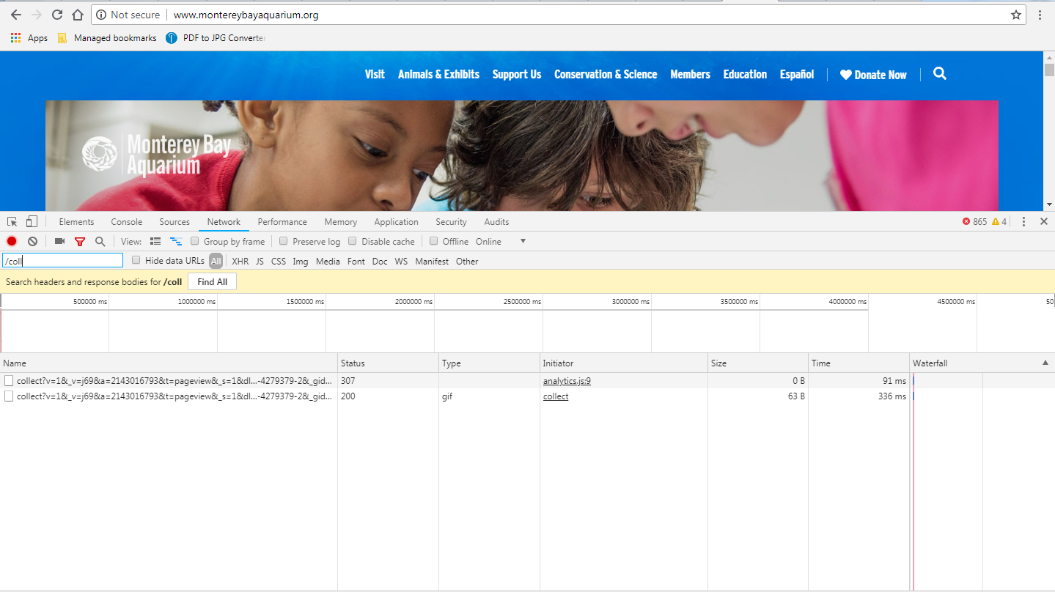

www.oberlo.in/ecommerce-wiki/google-tag-manager

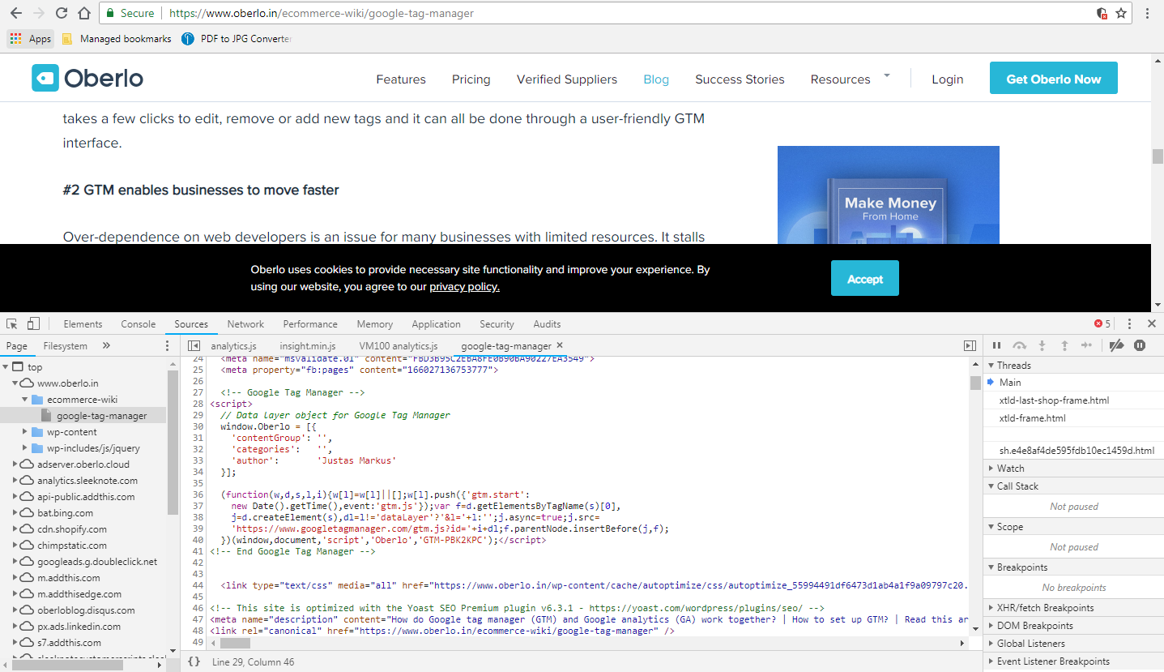

Adobe Analytics

In network => /ss,b/ss

Find in source code => dtm

Website using Adobe Analytics

local.pavilions.com

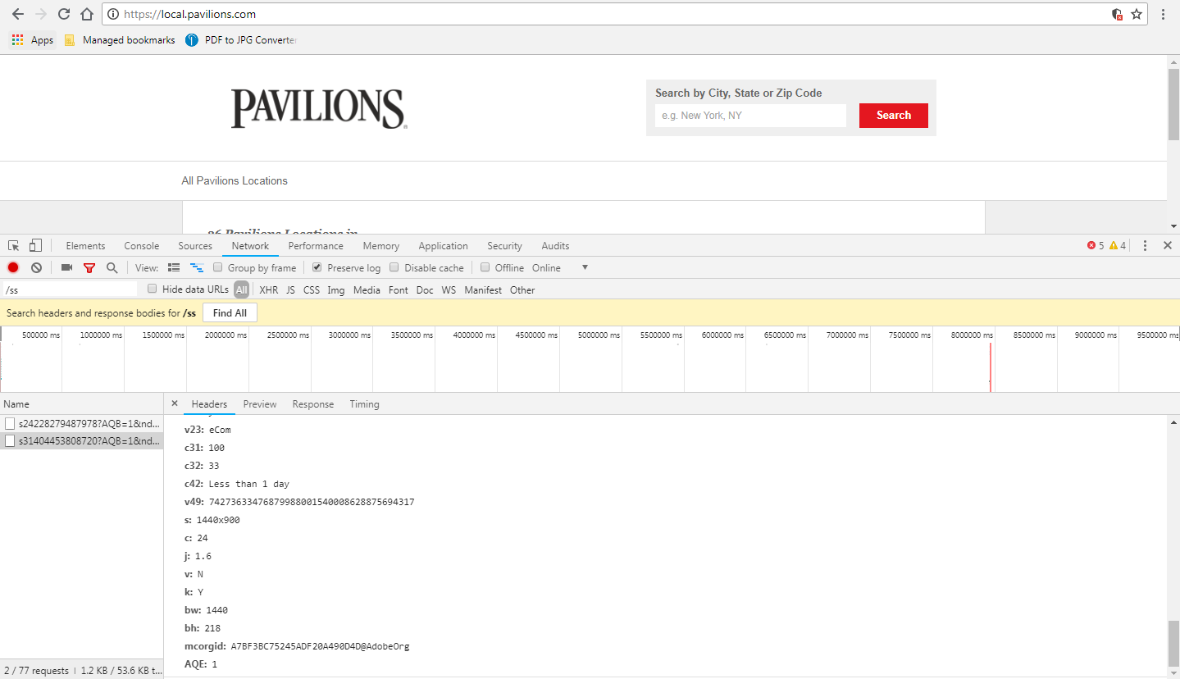

www.cars.com

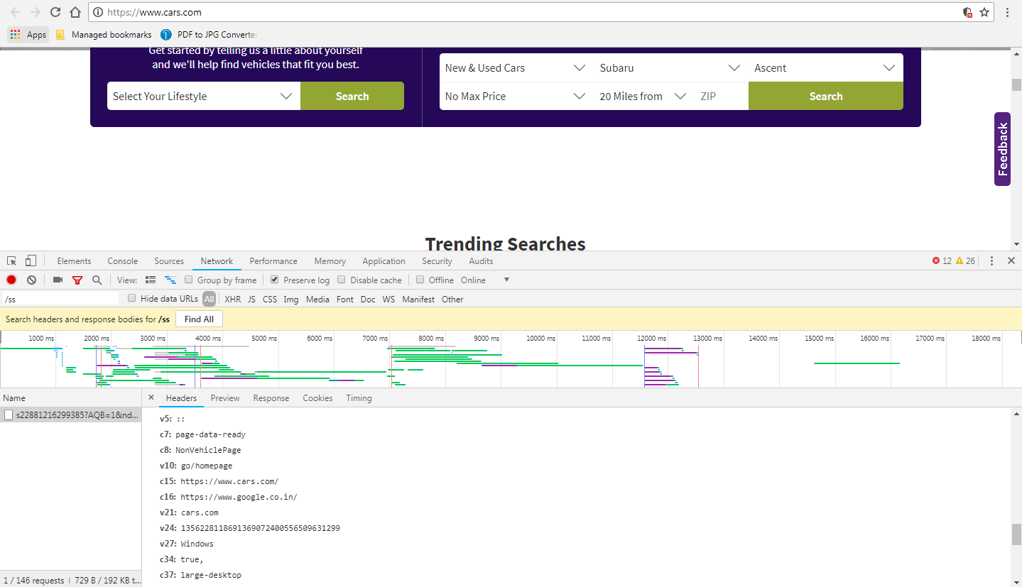

www.makemytrip.com

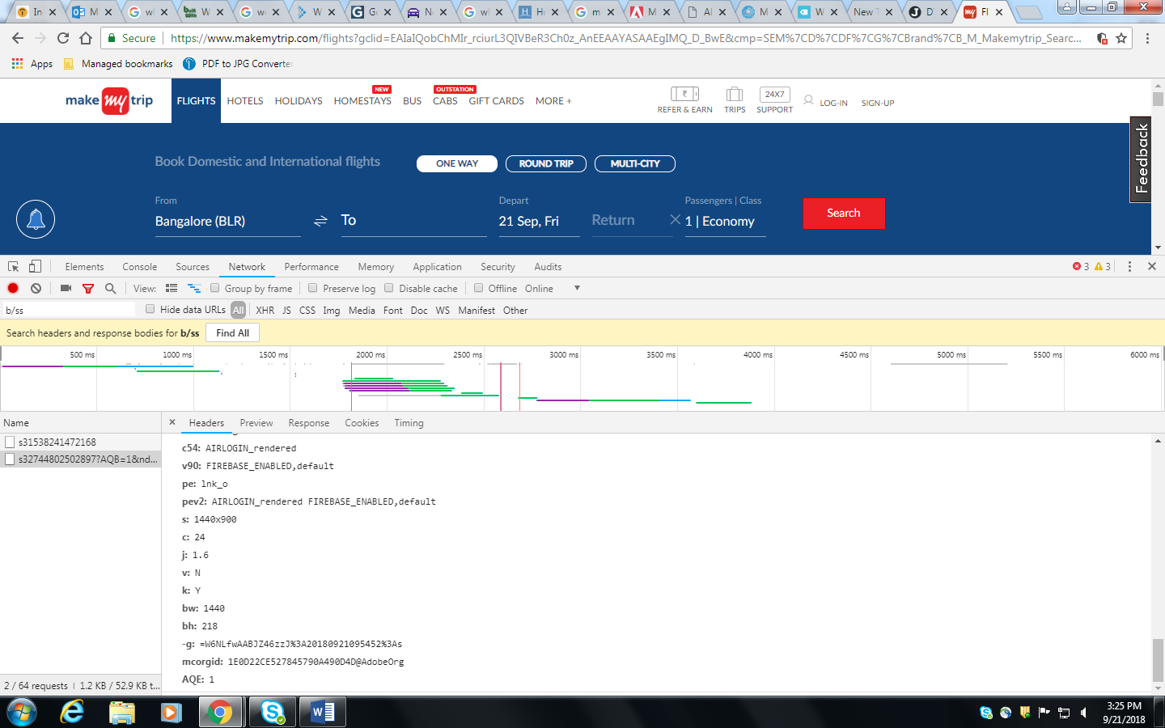

Tealium

In network => /analytics.js, /ss, /collect

Find in source code => tealium universal tag(utags.js)

[www.uber.com/en/in/](http://www.uber.com/en/in/)

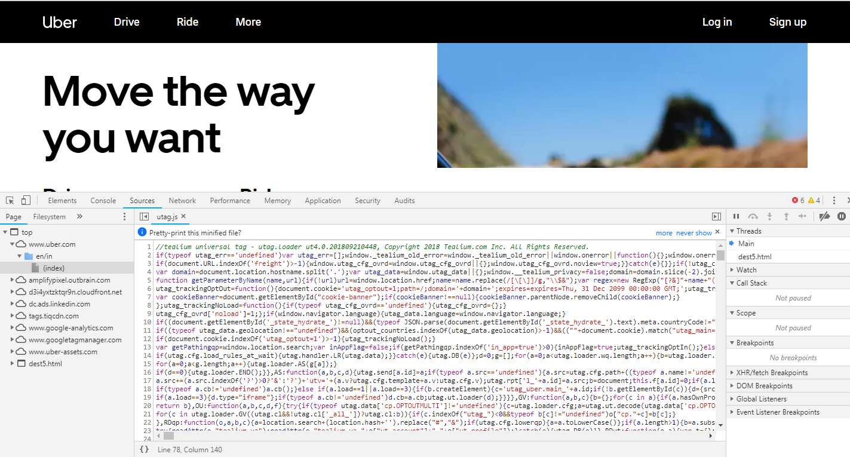

www.marksandspencer.com

